January 2022
Cox Automotive reveals market forecast for Q1 2022
- Cox Automotive predicts Q1 2022 to end on 506,804 new vehicle registrations
- New car production issues to remain until 2023
- Profitability and margin retention plays a significant part in retailers' strategies.

Registrations for new vehicles could reach 506,804 by the end of Q1. That's the most-likely scenario forecast by Cox Automotive upon the launch of its latest quarterly AutoFocus publication.

This represents a +19.1% increase year-on-year, but -23.7% down compared to the 2000-2019 average and -27.7% down compared with the most recent pre-pandemic 2019 performance. Cox Automotive's most likely scenario forecasts that the year will end on 1,878,806 registrations. This is a +14.1% increase year-on-year, but -18.7% down compared to the 2000-2019 average and the most recent 2019 pre-pandemic performance.

A sense of déjà vu

Philip Nothard, Insight and Strategy Director at Cox Automotive, believes a sense of déjà vu is setting in as the industry approaches the end of the first full month of trading.

Nothard said: "The start of a new year is often seen as an opportunity to start anew, to move on from the trials and tribulations of the previous year and set our sights on a better future. This is undoubtedly the case in the automotive industry after more than a year, dogged by new car production issues, increased lead times and skyrocketing used car values. However, while retailers have remained resilient and adapted to today's trading environment, there's still no sign of an immediate return to normal."

Nothard warns that the hopes of material shortages improving in early 2022 have rapidly fallen away and that we are unlikely to see much improvement until at least early 2023. Although the industry has responded well to being remarkably adaptable throughout the pandemic, it must continue to do so while this volatile and uncertain trading climate continues.

He added: "While the microchip and material shortages continue to affect the production of new cars and vans worldwide, some manufacturers such as Citroen and Polestar managed to increase production to the extent that sales targets were hit. However, recoveries are very manufacturer-specific, and we cannot expect normal volumes to return until 2023.

"Microchip shortages are causing a major headache but transitioning to Electric Vehicles (EVs) also impacts supply chains. Factories must be reconfigured to accommodate EV production and other alternatively fuelled vehicles. These changes don't happen overnight, but they are necessary to move towards cleaner and greener personal transportation."

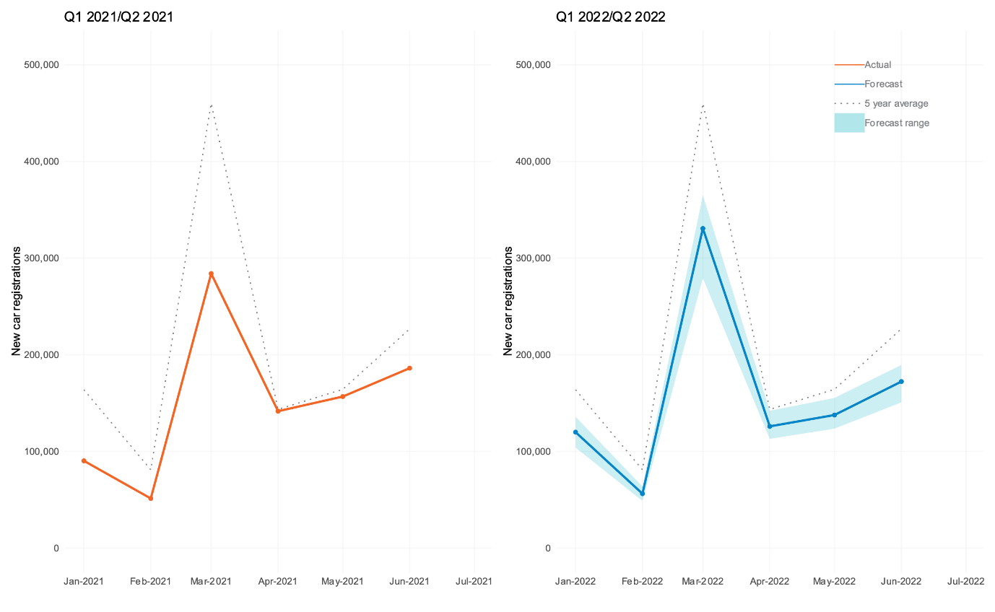

Consumers are becoming more understanding.

While the new car market struggles, the new LCV market in 2022 could be one of the strongest ever on record in the UK. According to Matthew Davock, Director of Commercial Vehicles at Manheim UK. Due to peak demand and thousands of orders of new LCVs from the major fleet, rental, and leasing sector, as many as 405,000 new vans are due to arrive ready for work in the UK if manufacturers find the perfect solutions to accelerate these production volumes.

Nothard concludes: “Despite all this, the good news for the industry is that consumers are now aware of the factors stalling new vehicle production, a factor that led to the rise in used car prices as buyers turn towards nearly new models. Retailers can use this to their advantage in their profitability and margin retention strategies since there are still ways to make a profit from new vehicle registrations when targets and volumes aren't being chased.”

We reveal the answers to these questions and much more in the new issue of AutoFocus.

Read more here: https://bit.ly/3g1mIVO.

Ends.
For all media enquiries and picture requests, please contact:
tim.gearey@coxautoinc.com | 07712 557 867

About Cox Automotive Europe

Cox Automotive Europe is driving the digital transformation of defleet, remarketing, retail and mobility operations for our manufacturer, fleet and retailer customers in the UK and EU.

As part of Cox Automotive, the world's largest automotive service organisation, we're transforming the way the world buys, sells, owns and uses vehicles. We work in partnership with our customers to not just provide dependable solutions that improve performance and profitability throughout the vehicle lifecycle today, but to innovate and prepare for the opportunities of tomorrow.

Our businesses are organised around our customers' core needs across vehicle solutions, remarketing, funding, retail and mobility. Our product brands in Europe include Manheim, Manheim Express, Dealer Auction, RMS Automotive, Movex, NextGear Capital, Modix, Codeweavers, eVA Valuations & Appraisals, Spiers New Technologies, FleetMaster and money4yourmotors.com. Cox Automotive Europe employs more than 2,500 team members and works with thousands of businesses throughout the wholesale and retail automotive markets.

Cox Automotive Europe is an operating division of Cox Automotive International and part of Cox Automotive, the world's largest automotive service organisation. Cox Automotive International represents our three core markets outside of the US and Canada - Europe, Australia & New Zealand and Brazil - and emerging markets in China and India.

coxautoinc.eu

