16th December 2020

MID-MONTH REVIEW – DECEMBER 2020

Philip Nothard, Insight & Strategy Director for Cox Automotive UK, shares his brief observations on the trends emerging in the car market this month.

Supply and demand are helping to maintain used car prices
Despite all the uncertainty surrounding the automotive industry and the broader economy since the end of the first lockdown, the one thing that has remained consistent is wholesale demand. Although we saw a slight dip in November, no doubt as a result of the second national lockdown, demand has so far increased slightly this month to 89.9 indexed points, helping to sustain a stable used car market.

However, supply this month has dropped off to 61.7 indexed points as vendors shift their focus to 2021 and hold back stock. Average age and mileage of auction stock this month has seen a slight increase as a consequence as vendors keep hold of newer stock until the new year.

Although a drop in supply is usual at this time of year, the disparity between supply and demand has helped to keep wholesale prices and auction conversions high.

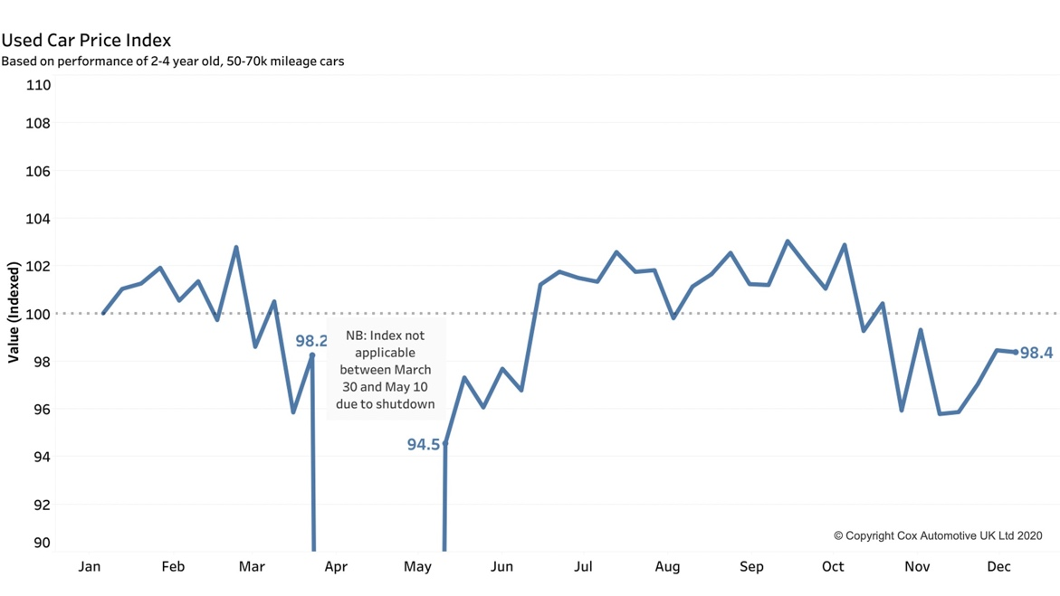

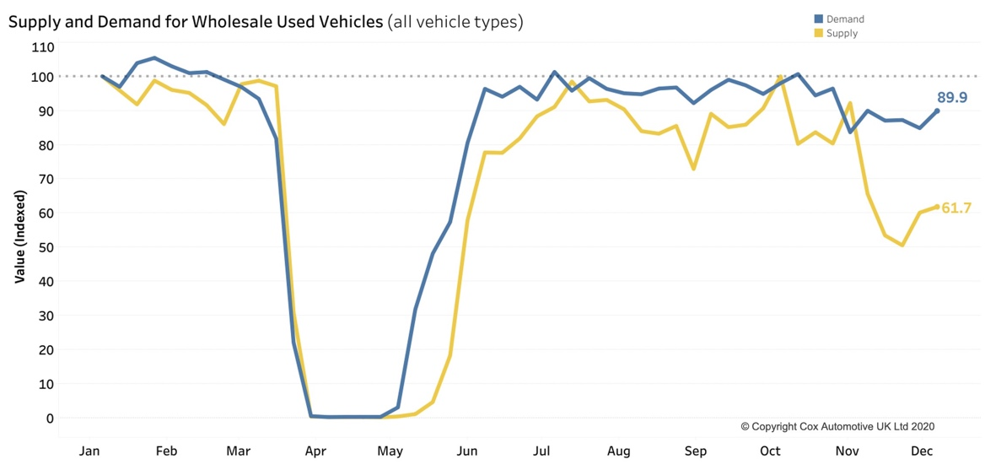

Unseasonal new car activity could increase 2020 new car forecast
The new car market has seen a slight boost at the end of the year, outperforming expectations due to unseasonal dealer activity. The risk of a no-deal Brexit is a concern to retailers, and as the likelihood of us crashing out of the EU increases, so does the number of 2020 new car registrations as dealers seek to register vehicles ahead of the 31st December deadline.

In our 2020 Insight Report, we forecast 1.57m registrations in 2020 (-32% YOY). This is likely to be exceeded if the uncertainty of a last-minute Brexit deal remains.

Not all of the boost is down to Brexit uncertainty. OEMs have also focused on registering physical stock to try boost 2020 market share recovery. In the dealer sector, we see increased activity with the taxation of derogation and fully paid vehicles.

The market is facing a lot of uncertainty going into 2021
As we come to the end of a turbulent year in automotive, Q1 2021 remains hard to predict due to a number of factors.

The effects of a potential no-deal Brexit are already being felt across the industry. I’ve heard that some planned shipments into Northern Ireland in the early parts of 2021 have been stopped by some retailers while it remains unclear what rules they will be operating under come 1st January. Despite the possibility of a late deal, the news has come too late for many retailers, and this could have a significant impact to supply in Northern Ireland at the start of the new year.

It also remains to be seen whether the current market can be sustained into the new year. Pent up demand in Q3 has undoubtedly created a false sense of a robust motor retail sector, and the bubble will likely burst for used car prices at some point in the near future once supply picks up.

Ends.
For all media enquiries and picture requests, please contact:
tim.gearey@coxauto.co.uk | 07712 557 867
About Cox Automotive UK
Cox Automotive is the world's largest automotive service organisation. We provide dependable solutions that improve performance and profitability throughout the vehicle lifecycle to manufacturers, fleets and dealers. Our businesses are organised around our customers’ core needs across vehicle solutions, remarketing, funding, and retail. Cox Automotive brands in the UK include Manheim, Dealer Auction, NextGear Capital, Modix, Movex, wewantanycar.com and money4yourmotors.com. The group employs more than 2,500 team members in the UK and works with thousands of businesses throughout the automotive industry. For more information, visit www.coxauto.co.uk.
About Manheim
Manheim UK is a leading provider of integrated products and services for the vehicle remarketing sector. With its network of 15 physical auction centres, online sales channels, vehicle solutions centres, transport and inspection solutions, and valuation tools, Manheim serves thousands of customers across the UK automotive industry. Manheim employs over 1,500 people in the UK, and is part of Cox Automotive, the world's largest provider of automotive services. Manheim's sister companies in the UK include Dealer Auction, NextGear Capital and Modix.

