MID-MONTH REVIEW – OCTOBER 2020

Philip Nothard, insight & strategy director for Cox Automotive, shares observations on trends emerging in the car market at the mid-point during October.
Demand remains stable for now but expect it to ease into Q4.
Since lockdown lifted back in June, demand for used vehicles has been relatively stable. However, as more localised lockdowns are introduced across the country, we could see reduced consumer confidence and demand easing in Q4.
Supply on the other hand - which has consistently tracked below demand since June reopening – has seen a steady increase throughout September and the first half of October, currently sitting at +3 index points ahead for the first time this year.
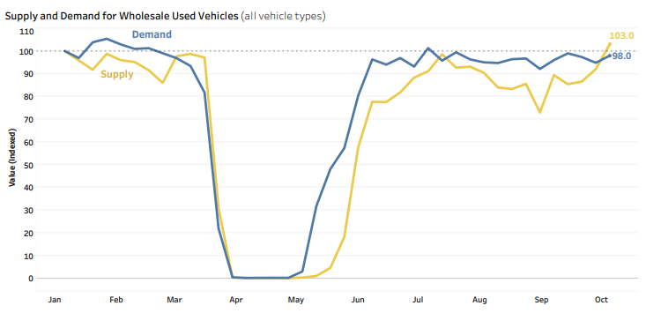
© Copyright Cox Automotive UK Limited 2020
w/e. 11th October 2020

Wholesale prices add to dealer cash flow concerns.
Cashflow concerns are growing across the automotive sector as the UK experiences localised lockdowns. Retailers are becoming increasingly cautious about their stocking levels and stock investment as we approach the end of the year, not helped by record auction prices.
With used car prices holding firm at +2.8 index points, these concerns are likely to continue for a while. However, as more supply enters the market, we expect to see some levelling in the market in Q4.
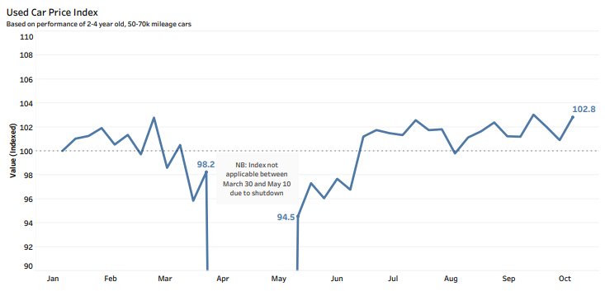
w/e. 11th October 2020
© Copyright Cox Automotive UK Limited 2020

-4.4% new car registrations in September doesn’t tell the whole story.
Although the headline figure of a -4.4% (-15,214) drop in registrations year-on-year isn’t as bad many predicted, it’s important to remember that this is still over 100k registrations behind a typical September registration month. 2020 has been the weakest year on record since the dual-plate introduction in 1999, illustrating the pressures on supply and the fleet and business sectors.
On a positive note, electric and hybrid vehicle registrations all performed well in September. Concerns remain though as to whether the accelerated EV ambitions by the Government are being sufficiently supported by incentive packages and infrastructure.

Ends.

For all media enquiries and picture requests,
please contact: tim.gearey@coxauto.co.uk | 07712 557 867

About Cox Automotive UK
Cox Automotive is the world's largest automotive service organisation, providing solutions to our clients at every stage of the vehicle lifecycle. We help dealers, manufacturers, fleet and leasing companies to boost the value of their assets, improving performance and profitability. In the UK, Cox Automotive provides inventory, financial, media and retail solutions to clients including franchised and independent dealers, car supermarkets, vehicle manufacturers and fleet and leasing companies. Cox Automotive brands in the UK include Manheim, Dealer Auction, Movex, RMS, NextGear Capital, Modix, wewantanycar.com and money4yourmotors.com. The group employs more than 2,300 team members in the UK and works with thousands of businesses throughout the automotive industry. For more information, visit www.coxauto.co.uk

