18 February 2019

USED CAR TRANSACTIONS TO EXCEED 2 MILLION IN Q1 2019,
PREDICTS COX AUTOMOTIVE

- Cox Automotive forecasts 2.02 million used car transactions in first quarter of 2019
- SMMT used car figures show 7.9 million transactions last year, within 1% of the Cox Automotive forecast
- Used car transactions set to exceed 2 million for the fourth year in a row in Q1
The used car market will reach 2.02 million transactions by the end of March, according to new research from Cox Automotive.
The forecast follows recent used car figures from the SMMT that confirm a total of 7.9 million transactions in 2018, a fall of -2.1% year-on-year.
The final SMMT figure was within 1% of Cox Automotive’s first long-range forecast, published in August, and the business is now forecasting 2.02 million transactions in the first quarter of 2019.
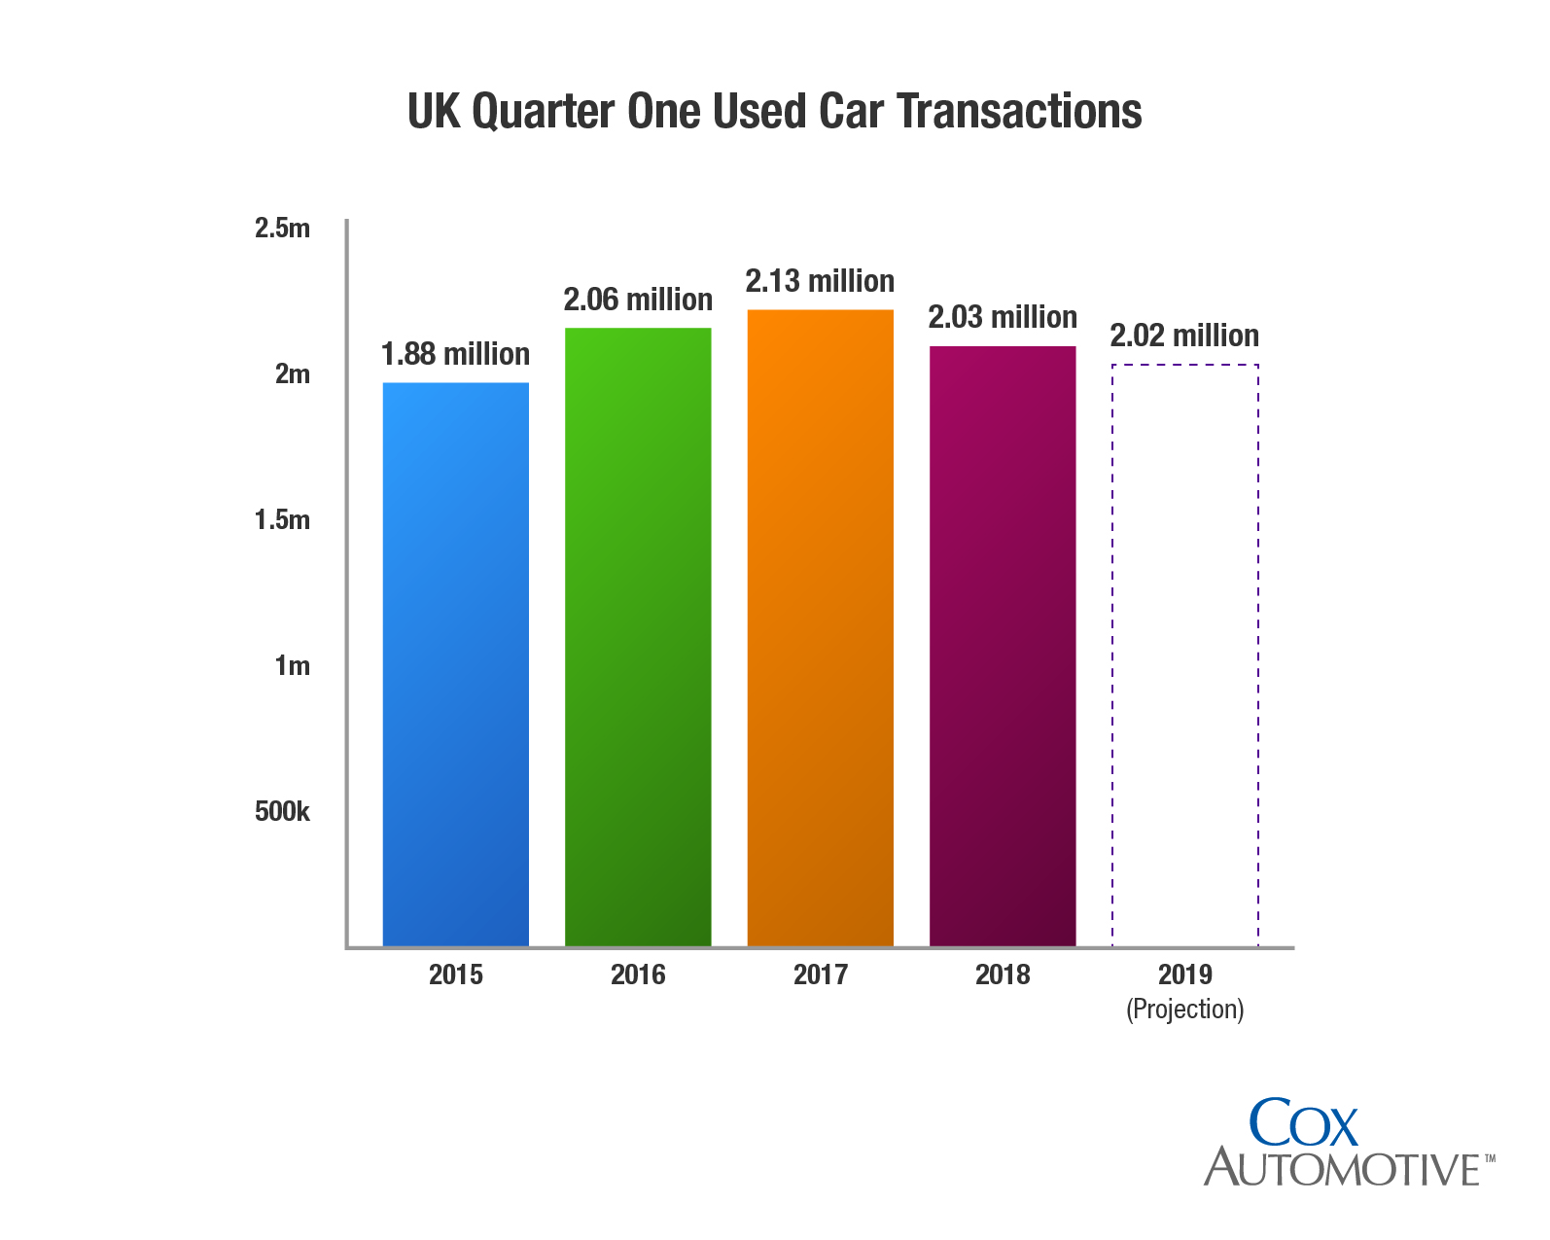
Philip Nothard, Cox Automotive UK’s Customer Insight and Strategy Director, said: “2018 was a good year for the used car market when you consider the uncertainty around Brexit, the economy, and the effects of WLTP.
“In contrast to new car sales, there was more stability in the used market and, as a result, many dealers have switched their focus from new to used.”
Cox Automotive issued its first ever market forecast back in August 2018, predicting that the used market would reach 7.86 million transactions by the end of the year. The forecast uses statistical analysis to combine data from Cox Automotive, SMMT change of ownership figures, and the latest projections on the UK economy.
Nothard continued: “To be within 1% of the SMMT figure with our long-range 2018 forecast is testament to the expertise within our data solutions team.
“Our forecast of 2.02 million used car transactions in the first quarter of 2019 represents a modest decline of 0.6% on 2018, but still gives an encouraging outlook for used car retailers and finance providers. This would represent the fourth year in a row that used car transactions have passed the two million mark - a fantastic achievement that shows the strength of the market.”
The SMMT figures also highlighted some interesting trends around fuel type in the used car market, with sales of hybrid, plug-in hybrid and battery electric cars up 27% year-on-year.
According to the last communication from Mike Hawes, SMMT Chief Executive, the results for low emission vehicles were encouraging, although sales remain low as an overall proportion of the market. He also pointed out the need for the right government policies and incentives to give new car buyers the confidence to choose the cleanest vehicles.
Nothard concluded: “2018 was the first year that alternative fuel vehicles were available in the wholesale market in any quantity, and the growth in used car sales is certainly encouraging.
“While diesel transactions held steady in 2018, the used-car market is starting to see the impact of reduced diesel registrations over the last three years. Availability of nearly-new diesel cars will certainly fall during 2019, although prices are likely to remain in line with the market in general.”
As the world’s largest automotive service organisation, Cox Automotive can combine data from across the entire vehicle lifecycle. In 2018 the business published its first Insight Report, offering analysis and discussion on some of the biggest topics in the automotive industry. The 2019 Insight Report will be available later this year, and Cox Automotive will also share more of its forecasting and market insights with the automotive sector over the coming months.
- Ends -

Notes to editors

2019 Used Car Forecast Methodology
Cox Automotive’s statistical analysis of the used car market uses Society of Motor Manufacturers and Traders (SMMT) change of ownership data up to December 2018. The analysis tracked year-on-year and seasonal trends using an ARIMA (AutoRegressive Integrated Moving Average) model, which makes predictions for future months. The forecast was moderated using the latest projections on the economy from GFK and Office for National Statistics. Further notes on the methodology will be published on www.coxautodata.com in due course

Enquiries
For all media enquiries and picture requests, please contact:
kate.rooney@coxauto.co.uk | 07824 897845
tim.gearey@coxauto.co.uk | 07468 691675

About Cox Automotive UK

Cox Automotive is the world's largest automotive service organisation, providing solutions to our clients at every stage of the vehicle lifecycle. We help dealers, manufacturers, fleet and leasing companies to boost the value of their assets, improving performance and profitability. In the UK, Cox Automotive provides inventory, financial, media and retail solutions to clients including franchised and independent dealers, car supermarkets, vehicle manufacturers and fleet and leasing companies. Cox Automotive brands in the UK include Manheim, Dealer Auction, Movex, RMS, NextGear Capital, Modix, wewantanycar.com and money4yourmotors.com. The group employs more than 2,300 team members in the UK and works with thousands of businesses throughout the automotive industry. For more information, visit www.coxauto.co.uk.

About Cox Automotive

Cox Automotive Inc. makes buying, selling, owning and using cars easier for everyone. The global company’s 34,000-plus team members and family of brands, including Autotrader®, Clutch Technologies, Dealer.com®, Dealertrack®, Kelley Blue Book®, Manheim®, NextGear Capital®, VinSolutions®, vAuto® and Xtime®, are passionate about helping millions of car shoppers, 40,000 auto dealer clients across five continents and many others throughout the automotive industry thrive for generations to come. Cox Automotive is a subsidiary of Cox Enterprises Inc., a privately-owned, Atlanta-based company with revenues exceeding $20 billion. www.coxautoinc.com

