RETAIL MARKET DEFIES EXPECTATIONS
TO REVEAL STRONG AUGUST

Figures released today by Cox Automotive have revealed a surprising August for the retail market as the ongoing pressures surrounding new cars were offset by an increased demand for used.

Despite 39% of the dealers that responded to Cox Automotive's latest dealer survey reporting a year on year drop in footfall during the holiday season, the market held steady in terms of sales.

Car search platform, Motors.co.uk, reported a year-on-year improvement in days in stock, with vehicles selling on average 3% quicker in August 2018 vs. August 2017 (down 2 days to 38 days), while the average sold price of vehicles held steady at £14,370 (up 4.4% on August 2017).

Ongoing media pressures also failed once again to affect fuel choice. Diesel vehicles continued to sell well (six days faster than the same period last year) while petrol vehicles remained on forecourts for an average of 37 days, the same as last year. In contrast, hybrids sold an average two days slower (41 days) than last year.

The used retail market also profited from the good weather throughout the month, as dealerships across the country reported an increase in demand for convertibles, selling six days quicker than August 2017, while coupes also experienced an upturn, selling five days faster than the same period last year.

Commenting on the figures, Cox Automotive's Philip Nothard, said, "2018 really is the year of the used car. There were concerns the market may slow as we entered peak holiday season, however all reports show the demand for used remained stable, buoyed by the ongoing pressures in the new market caused by WLTP. It is a great accomplishment and has helped build confidence for the months ahead, despite the uncertainty around the WLTP regulations. "

"As expected, convertibles and coupes sold well, with consumers taking advantage of the hotter than average temperatures, but we have also seen signs of 4x4 sales picking up as we enter the Autumn season. Diesels are also performing well, and demand remains healthy."

"Moving forward, it's likely supply will tighten over the coming months, so stock management and maximising margins will be crucial for dealers.

"Dealers who have invested in larger models for their stock profile would do well to begin showcasing these vehicles prominently on forecourts as we move through September to benefit from increased interest and sales."

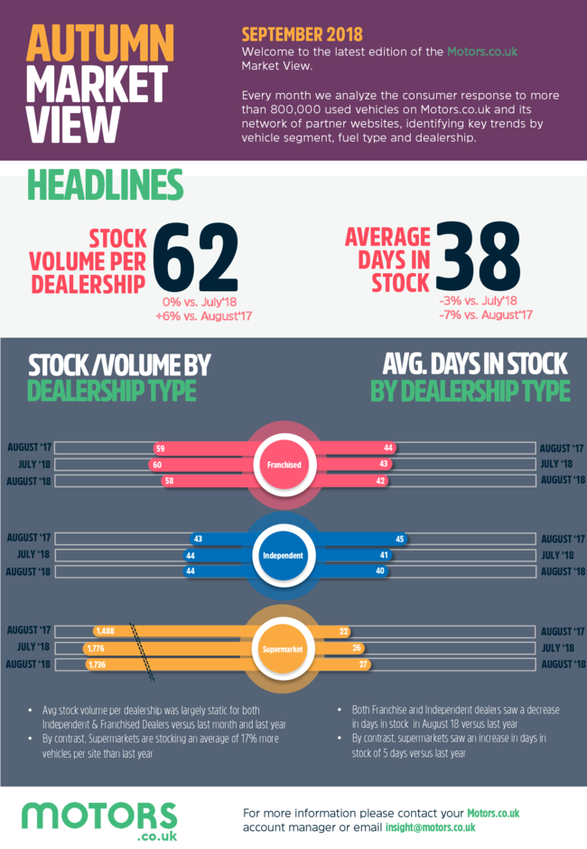 | Autumn market view  Click here to download the Autumn market view from Motors.co.uk  Every month Motors.co.uk analyses the consumer response to more than 800,000 used vehicles, identifying key trends byvehicle segment, fuel type and dealership.

